**Important Terminal Commands**

**1)** cd: **Change Directory / move to a specific Folder**

**[Windows & Linux]**

**(cd + ’directory’)**

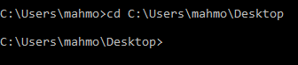

**(cd + ..)**: Step back

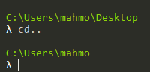

**(cd + part of command + tab)**: Auto completion



**(cd + \)**: Return to root

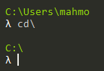

**2)** mkdir: **Create new folder(s) [Linux]**

**(mkdir + 'directory1' + 'directory2' + ...)**





**3)** cls: **Clear the screen [Windows]**

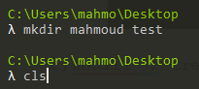



**4)** ls: **List information about file(s) [Linux]**

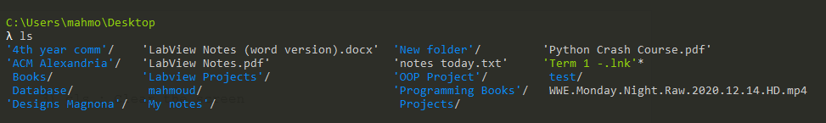

**5)** dir: **Display a list of files and folders**

**[Windows & Linux]**

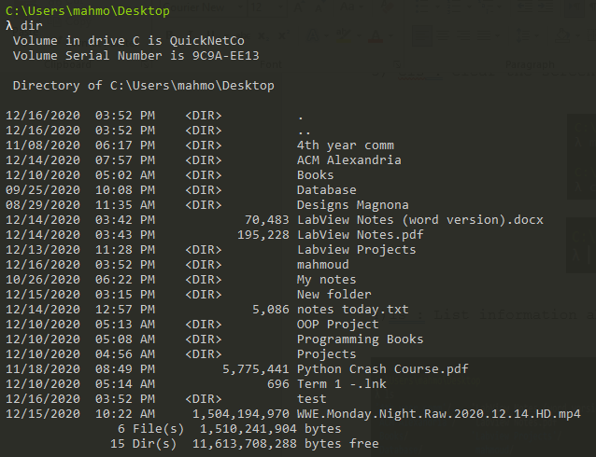

**6)** move: **Move files from one folder to another (can create the new folder(directory)) [Windows]**

**(move + 'directory_name' + 'new_directory_name’)**



**7)** mv: **Move or rename files or directories [Linux]**

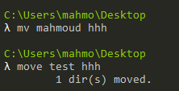

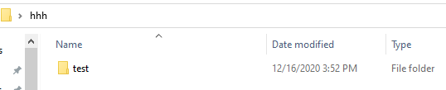

**8)** rename: **Rename files [Linux]**

**(rename + ‘file_name’ + ‘new_file_name’)**





**9)** cp: **Copy one or more files to another location**

**[Linux]**

**(cp + -r):** Copy recursively, non-directories as files





**10)** help: **Online Help [Windows & Linux]**

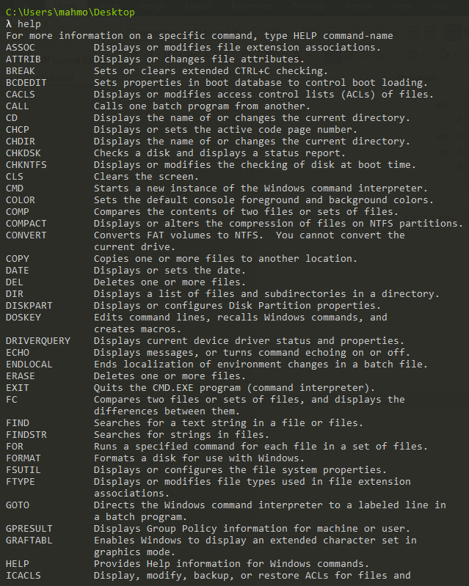

**11)** rm: **Remove files [Linux]**

**(rm + -r)**: Remove directories and their contents recursively



**(rm + -d)**: Remove empty directories



**12)** echo: **Display message on screen [Windows & Linux]**

**(echo + ‘msg’)**

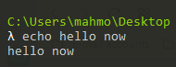

**(echo + ‘msg’ + > + ‘file_name’)**: Print a msg in this file or create it if it doesn't exist (overriding)



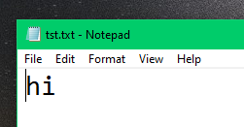

**(echo + "msg" + >> + 'file_name')**: Print a msg in this file or create it if it doesn't exist (appending)



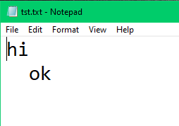

**13)** cat: **Concatenate and print (display) the content of the files [Linux]**

**(cat + 'file_name1' + 'file_name2' + ...)**: View files' content concatenated

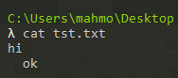

**(cat + “ “ + *)**: View files' content concatenated in the current directory

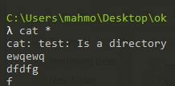

**(cat + 'file_name1' + > + 'file_name2')**: Concatenate the content of file1 to the content of file2 and put it in file2 (and create file2 if not existed)



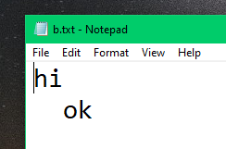

**14)** grep [Global Regular Expression Print]: **Search file(s) for lines that match a given pattern [Linux]**

**(grep + 'str' + 'file_name')**: Search for the str in the file and print it



**(grep + 'str' + -r +'file_name')**: Search for the str in the file(directory) and its root and print it



**(grep + 'str' + -r + -l)**: Search for the str in the current directory and list the files that contain it



**15)** exit: **close the cmd [Windows & Linux]**

**16)** file: **Determine file type [Linux]**

**(file +'file_name')**: Get the type of the file and its information

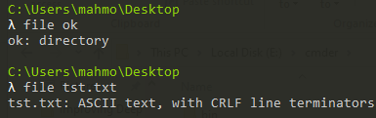

**17)** man: **Help manual [Linux]**

**(man + command)**: Get the manual of the command

**18)** (command + /?): **Get the manual of the command**

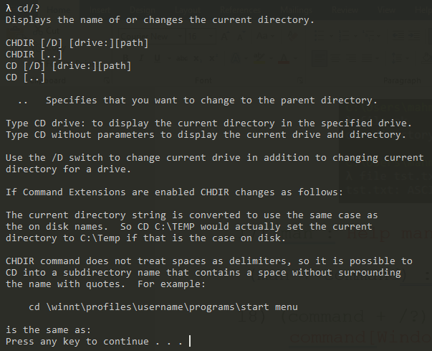

**19)** (ctrl + c): **Stops execution of any process**

**[Windows]**

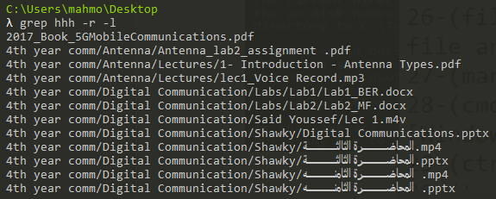

**20)** tree: **Graphical display of folder structure**

**[Windows]**

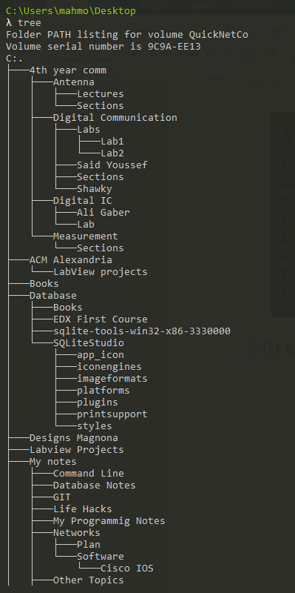

**(tree + /a):** Get the path(tree) of the current dir

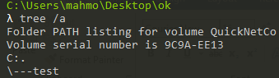

**21)** osk: **Opens the "On Screen Keyboard" [Windows]**

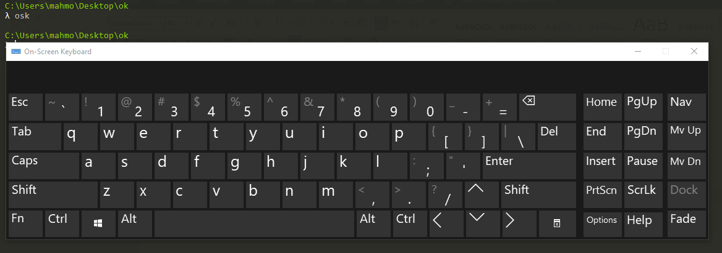

**22)** tasklist: **List running applications and services**

**[Windows]**

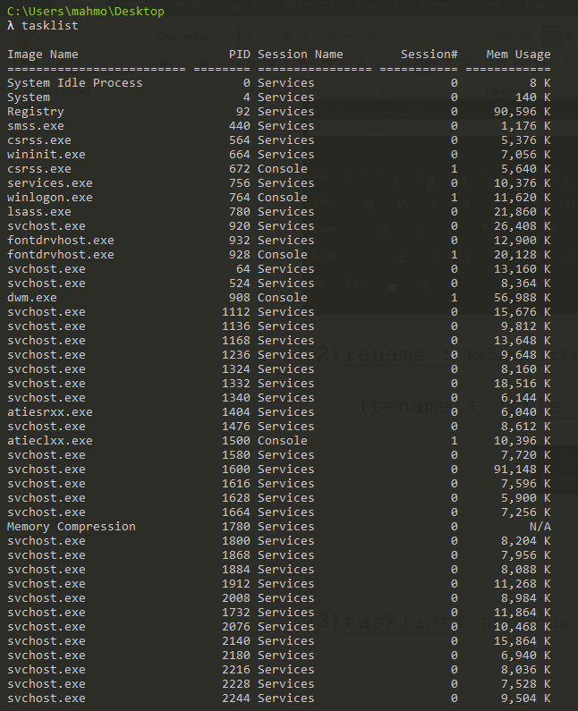

**23)** alias: **Create an alias [Linux]**

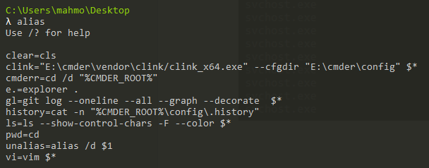

**(alias + command1=command2):** Make abbreviation of command1=command2

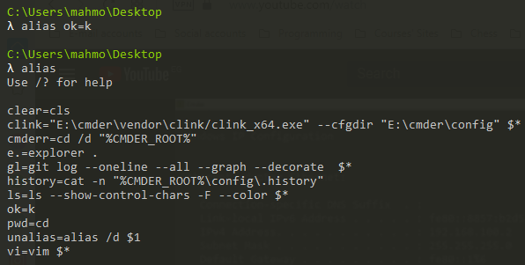

**(alias + /d + ’alias_name’):** Delete alias

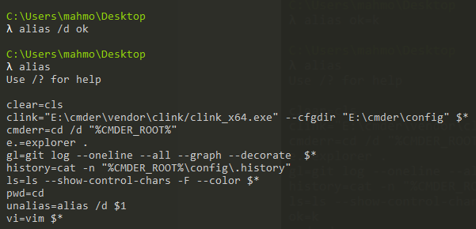

**24)** (command1 && command2 && …): **Execute multiple commands at the same time**



**25)** whoami: **Output the current UserName and domain**

**[Windows & Linux]**



**26)** ipconfig: **Configure IP [Windows & Linux]**

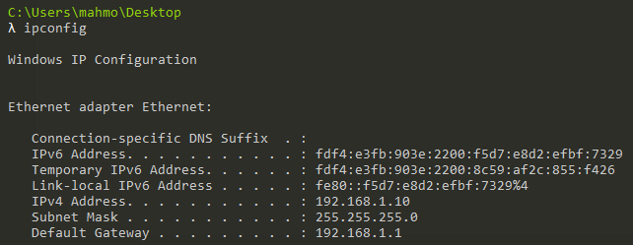

**(ipconfig + | + clip):** Copy the IP information to the clipboard



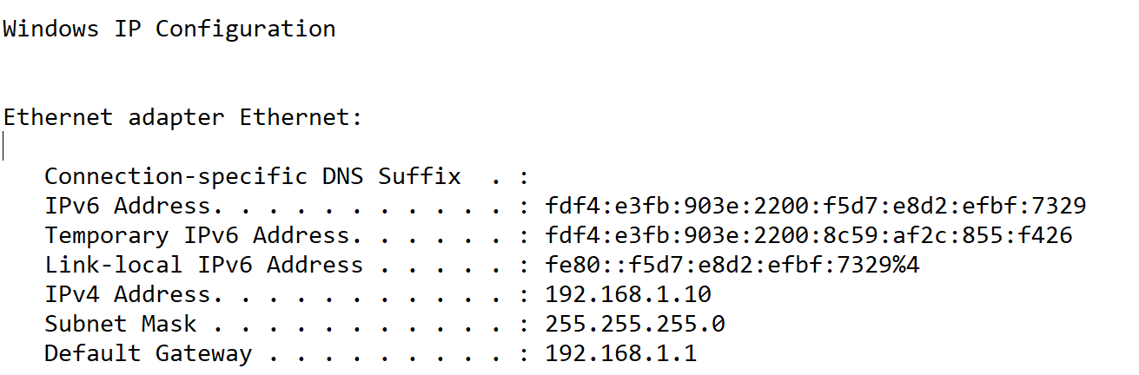

**27)** systeminfo: **List system configuration [Windows]**

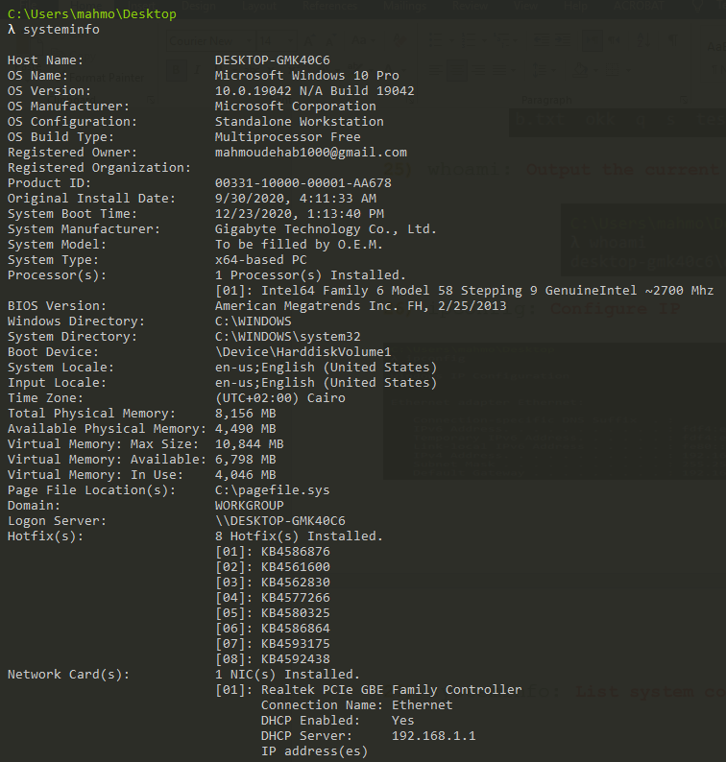

**28)** ping: **Test a network Connection [Windows & Linux]**

**(ping + ‘website_name’):** Test if the website is currently working

